GSWCC

DRAFT MEETING MINUTES

MEETING—February 7, 2023

# 10:00 AM - GSWCC - VIA ZOOM

The meeting was called to order by Chairman Bob Martin at 10:00 AM. The meeting was held in via zoom. Robert Amos gave the invocation

The following board members were present via zoom: Chairman Bob Martin Vice Chairman Vikki Consiglio, Kerry Van Moore, and Jason Winters attended via zoom, a quorum was established. Ellis Lamme, Gwinnett County District Chairman attended via zoom.

Attending members of the Commission were Executive Director Mitch Attaway, Conservation

Manager Robert Amos, Urban Program Manager, Ben Ruzowicz, Rural Project Manager Ben Hyer, Rural Project Manager Greg Walker, Karen Bruce, Office Manager, Josh Jackwood, Conservation Regional Manager for Region I, Jennifer Standridge, Conservation Regional

Manager for Region Il, NancyAnne Conner, Conservation Regional Manager for Region Ill, Michelle Conner, Conservation Regional Manager for Region IV, Ben Roberts, Conservation Regional Manager for Region V, and Stuart Suttles, Resource Specialist for Region Il, Leslie Peterson, Resource Specialist, Region IV, Amelia Nystrom, Resource Specialist for Region V, and Administrative Assistant Jacquline Holt attended via Zoom.

Mr. Attaway asked for approval of the minutes from the December 13, 2022 meeting. Chairman Martin called for a motion. There was a motion by Mr. Jason Winters to approve the minutes, a second by Ms. Vikki Consiglio and the motion carried to unanimous approval

Executive Director's Report - Mitch Attaway stated there is no old business. There was to be 4 new incoming employees, but there are only 3 new incoming employees. Unfortunately, 1 employee changed her mind the day before she was to start. There is 1 outgoing employee, Kim Worley, in the Calhoun office, will be leaving the Commission. Mr. Attaway stated that each District received an extra $2000.00 in the budget for this year and per Karen Bruce all have spent 2/3rds of that budget increase. He stated that roughly $66,000 was removed from the Commission budget due to hiring dates for new employees. Mr. Ellis Lamme questioned if Gwinnett County could get a copy of the minutes, agendas, and reports from the board meetings. Mr. Attaway said he would have Jennifer Standridge in charge of getting those to him.

Conservation Report —Mitch Attaway gave the Conservation Report. Mr. Attaway stated that there are 12 supervisors that need to be approved by the board. Mr. Attaway stated there is 1 resignation. Chairman Martin called for a motion on the appointments and resignation. Mr.

Kerry Van Moore made a motion to approve the  and resignation, a second by Ms. Vikki Consiglio and the motion carried to unanimous approval.

Urban Report —Ben Ruzowicz stated there had been 458 plan reviews completed since the last meeting. Mr. Ruzowicz stated that there have been 201 certification courses completed. 1005 people were in attendance for those courses. He stated that 792 were recertifications and 714 were new certifications. They are starting the overview process in Elbert and Banks counties, following up with overviews in the cities of Madison and Byron, and Clayton County passed their overview with a score of 438. He stated March 29, 2023 will be GSWCC Erosion Day at UGA. Mr. Ellis Lamme asked if there was a database listing for anyone who needs to recertify their Erosion and Sediment Certification. Ben Ruzowicz stated that anyone can look up whether someone is certified or not. He stated that courses are held almost every day and that reminders are sent when someone needs to recertify.

Rural Report Mr. Ben Hyer and Mr. Greg Walker, Rural Project Managers gave the attached report.

Public Comment: No Public Comment

Next Meeting: The next meeting will be April 11, 2023 at 10:00 a.m. via Zoom.

With no other business to discuss the meeting was adjourned by Chairman Martin at 10:52 a.m.

Respectively Submitted by:

Jacquline Holt

Approved by:

cid:image001.png@01D920E4.AFC20260 04/11/2023 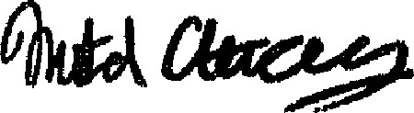 02/07/23

GSWCC Chairman Date GSWCC Executive Director Date

GACD Attendance:

Mark Masters — President

Katie Sponberger Executive Director

Leanne Hopper— Southwest Georgia Regional Program Manager

Katelyn Poppell — Southeast Program Manager Tabatha Wooten

NRCS Attendance:

Tansel Hudson,

Terrance Rudolph

Others in Attendance:

Alex Bradford

Jim's Ipad

Dominic LaRiccia

F. Woods

February 2023 Rural Water

# Watershed Dam Update

I. Noon Day 17- Construction drawings have been approved and a construction permit has been issued by EPD. There is one easement agreen•ent remaining that needs to be executed, Negotiations are in currently in progress with the landowner. Once it is executed, then bid documents will be released to the qualified bidders. An appraiser vislted the site on June 25 to determine the value of the easements. On September 29, Cobb SWCD voted to approve a resolutlon to offer the appraised value to the landowner for the temporary easements. A meeting is to be arranged with the landowner to deliver an offer letter.

2. Little River 25- Golder and Associates has submitted the Supplemental Watershed Plan to NRCS for final authorization. The pending design for the rehabilitation is 100% federally funded by NRCS, Design is complete for a permanent access road and stream crossing to be built to accommodate rehabilitation design and maintenance projects. Construction of the access road complete and clearing of trees from the embankment will begin soon. A request was submitted to NRCS for technical assistance with design drawings for a replacement trash rack.

Bull Creek 14- Construction is currently underway. 4, Bull Creek 12- Construction is currently underway.

1. Trion-Chattooga River Dike System- - Gotder and Associates has received comments from the NRCS National Headquarters. Comments will be addressed and final submittal is anticipated this month. Golder is in the process of advanced planning in anticipation of the SWP approval. Design is funded by NRCS pending approval of the Supplemental Watershed Plan.
2. Supplemental Watershed Plans„ 4 contractors are working on 12 watershed dan•s located in Cherokee and Forsyth counties. Contractors have or are submitting documents to GA-NRCS for review and development.
3. Maintenance Funds- Currently in various stages of dam maintenance projects in Madison County. Contracts have been executed for mowing bundles for previously cleared dams throughout the state with Rolling Hills RC&D and Chestatee" Chattahoochee RC&D.
4. Butl Creek 3- This project is a repair of the dam embankment. A contractor has been selected and onsite preconstruction meetings were held in January. Contractor coordination with moving spoil material from Bull Creek 12 is underway.
5. Assessments- 9 assessments and 7 emergency actions plans are under contract with 2 contractors and are due in August of 203.
6. Permitting- Currently in the process of contracting multiple engineering firms to submit permit applications to GA Safe Dams for watershed structures that can possibly be permitted "as is" or with only minor repairs,

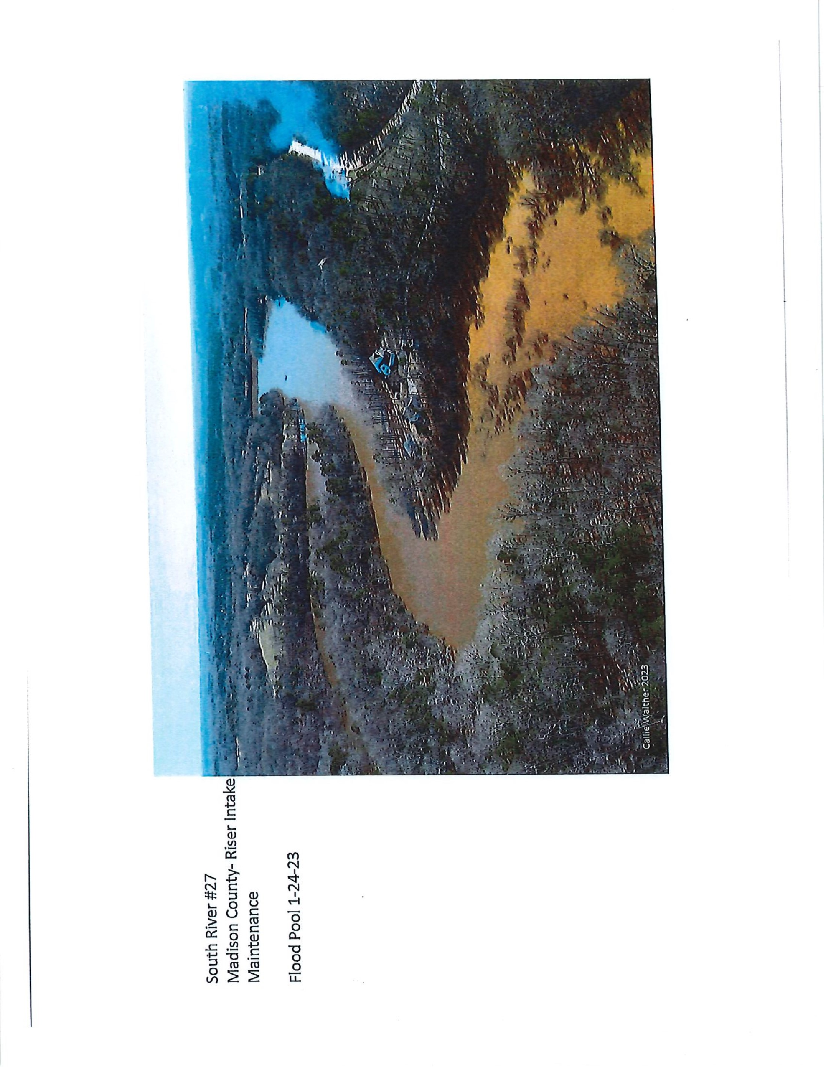

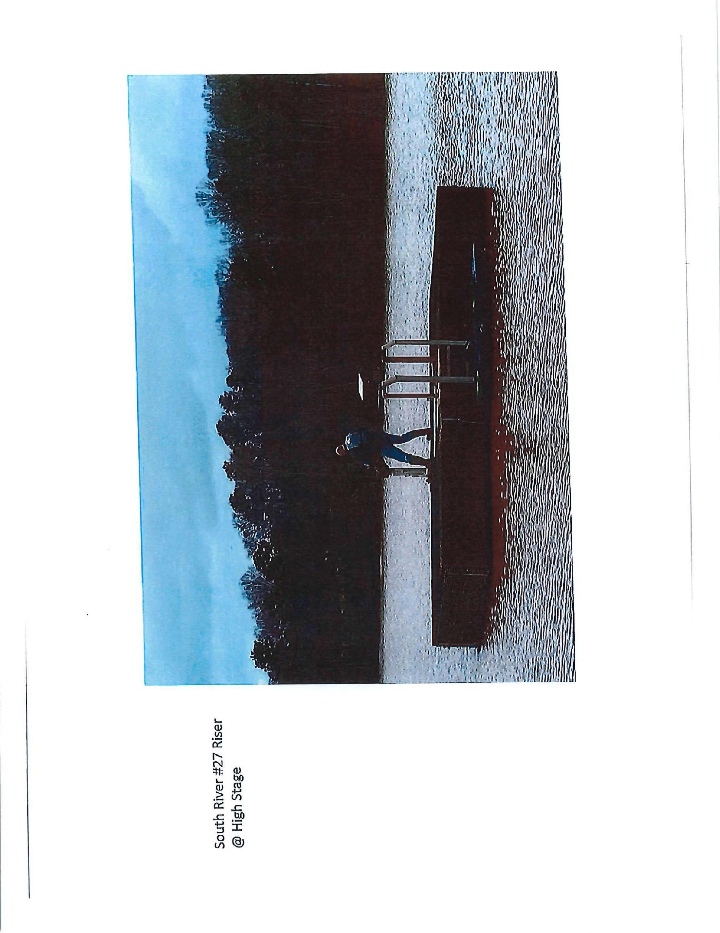

 eSueqo

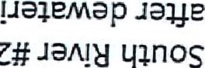

Z

1-14nos

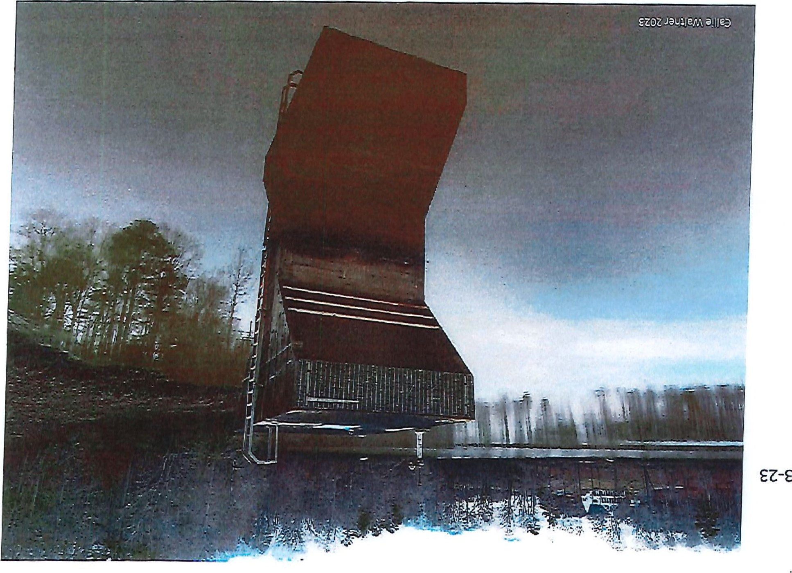

EZ-E-Z

|  |  |
| --- | --- |
| 후결츠우§닍니  -을•들훁 부! 들수!들盞•t*뗠들畺•  •.+13魯  •?身~彛2다로“ |  |

巨 0

8

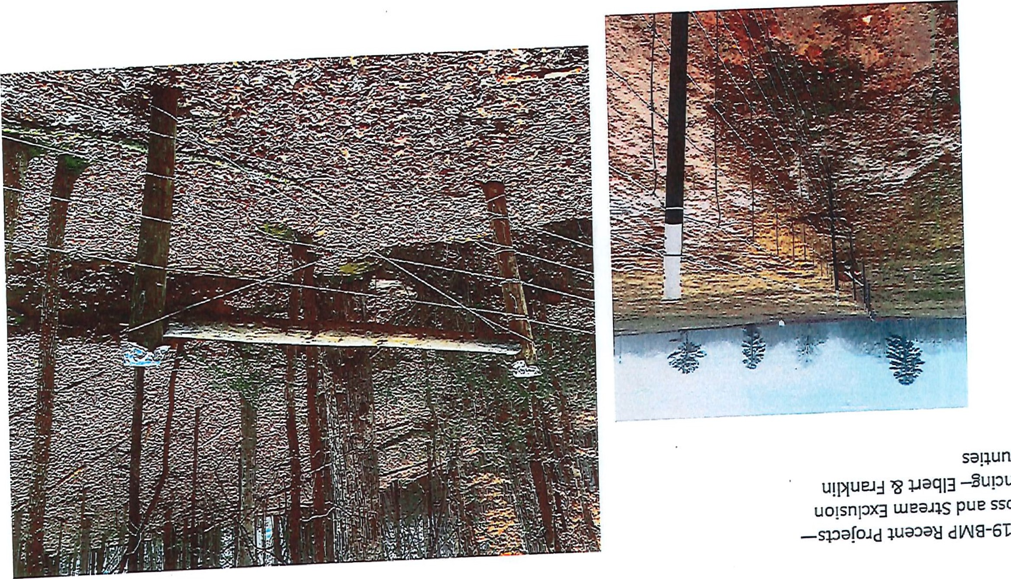S コ00 Suでu卍

# S50」

000,00」=0当 00=

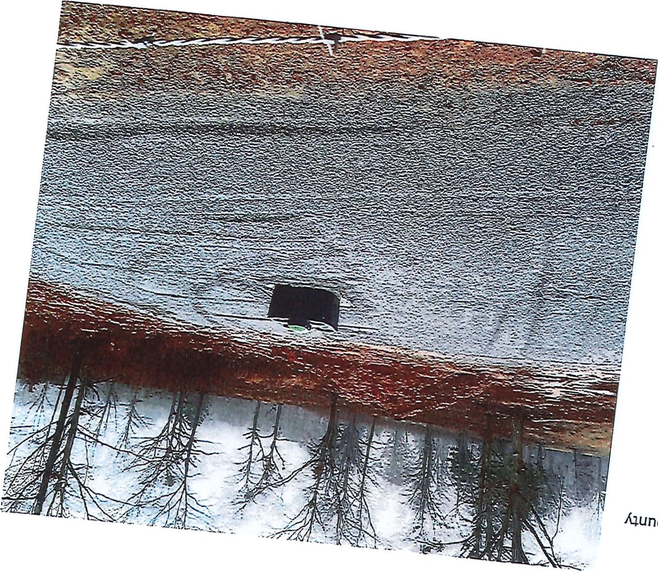

0000

## Grants U date

1. Watershed Management Plans (WMPs) for Chickasawhatchee Creek (Doughtery, Calhoun, and Terrell) and Coosawattee River-Cartees lake (Gilmer and Murray) have been completed. Through an agreement with GA EPD we are partnering with landowners to install best management practices (BMPs) within these areas to reduce nonpoint source pollutant loading into state waters,
2. New WMPs and funds for BMP implementation have been completed in the North Fork

Broad River-Middle Fork Broad River (Banks, Franklin, Habersham, and Stephens) and Wahoo Creek-Little River (Hall, Lumpkin, and White) through an agreement with GA EPD. Agricultural BMP projects are underway.

1. A BMP cost-share implementation project area tocated In Rooty Creek Watershed (Putnam) and Big Indian Creek Watershed (Morgan and Walton) has started. Work continues to advertise BMP project cost share opportunities.
2. A Resource Conservation Partnership with NRCS is curvently held and seeks to provide workshops statewide outlining available technical and financial opportunities available* "I-his partnership also seeks to promote the NRCS Standard Practice 340 for using Cover Crops. Golden Triangle RC&D and the UGA Extension office in Terrell County have completed their cover crop demonstration, GACD is partnering with districts to hold topical workshops.
3. A new Watershed Management Plan for Hard Labor Creek is being developed in Walton and Morgan counites with the assistance Of Tetra Tech, A new project coordinat05 is working on development of the WMP and the BMP cost share projects. A stakeholder meeting is being planned in order to provide comments on a new outline for Poultry and Cattle production sector specific manuals expanding upon the BMP for Georgia Agricultural Manual.