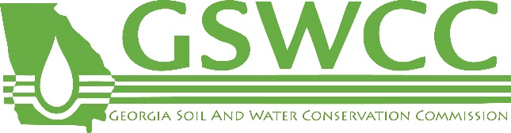

GSWCC Level 1B Certified Inspector of the Year
2020 ABOVE AND BEYOND AWARD NOMINATION FORM

Do you know a colleague, or even yourself, who has gone “above and beyond” in carrying out everyday responsibilities of a GSWCC Level 1B Certified Inspector? If so, we want to recognize that person at the 2020 GSWCC Erosion Control Day on March 19th! Submit details about their efforts using the nomination form below.
In describing the rationale for this award nomination, please include how the nominee went “above and beyond” in the areas of dedication, follow-through, extra effort, attitude, and hard work, and displayed that extra “WOW” factor in getting the job done.
HOW TO SUBMIT THE FORM
- FORMS ARE DUE BY MARCH 2nd
- All nomination forms are to be submitted by email to jennifer.howell@gaswcc.ga.gov
- Include “Level 1B Nomination” in the subject line of the email
GSWCC Level 1B Certified Inspector of the Year Nominee Information:
Name | Company
Phone | Email
Certification Number or Address of Nominee
Name, Phone, and Email of Person Nominating

Describe the attitude generally displayed by the nominee on the job:
Describe the follow-through generally displayed by the nominee on the job:
Describe the dedication displayed by the nominee on the job:
Describe the hard work or extra effort put forth by the nominee on the job:
Describe any “WOW” factor the nominee has displayed in getting the job done:
Submit form by email to Jennifer Howell: jennifer.howell@gaswcc.ga.gov

